**Universal Healthcare System**

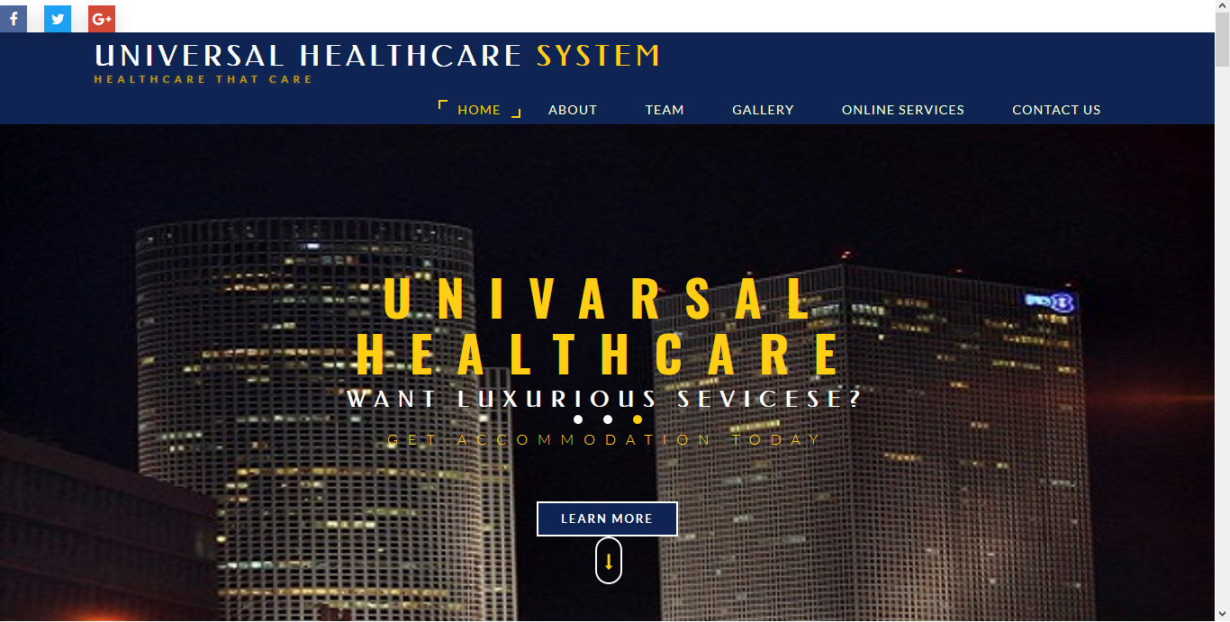**Health care that care.**

Introduction

The term healthcare system refers to a country’s system of developing services for the prevention and treatment of diseases and for the promotion of physical and mental wellbeing. Today the healthcare industry has emerged as one of the largest services sector industries in Bangladesh. The Bangladesh economy over the recent past has started looking up and has now decidedly being acknowledged as likely to continue to sustain economic growth. The Bangladeshi healthcare industry through still at the developing stage and dynamics compared to other countries. A county’s healthcare system also reflects in part of the culture and values of the society.

Statement of the Problem

The purpose of this study was to determine that how to face this problem and technology, environmental and medical overall improvement.

The Present Situation in Bangladesh

In present situation in Bangladesh people faces in healthcare problem which converted into many diseases. Healthcare problem in Bangladesh include communicable and non-communicable disease, malnutrition, environmental sanitation problems and also transport communication problem. In the current situation of Bangladesh per year more than four thousand people are died in road accident and the maximum people are die because they do not get faster medical services and also lack of basic amenities equipment. Universal Healthcare System provide in the country best services all over the country. It’s provide modern technology ambulance services and uses treatment modern technological equipment. Universal Healthcare System gives 24 hours services in all of the clinical and non- clinical department.

Technological Environment Analysis

Universal Healthcare System providing patient treatment with specialized medical and nursing staff and medical equipment. The emergency department treated as to the urgent health problems ranging from fire and accidental victims. It has large number of beds for intensive care and additional beds for patient who need long term care. In the year 2008 included the modern technology electronic medical records (EMR), clinical decision support (CDS), and computerized physician order entry (CPOE) also included bar-coding at medication dispending (BarD), robot for medication dispending (ROBOT) and automated dispensing machines (AMD).

24 Hours Help and Support

An emergency department (ED) also known as an accident & emergency department (A&E) due to unplanned nature of patient, the department provide initial treatment for a broad spectrum of illness and injuries. The healthcare has developed emergency unit and always ready for emergency treatment. 24-hours ambulance service for both air or street any adverse situation people get this service. In the healthcare people get doctors services in 24-hours. More than four thousand people get admitted and they can get appointment to a doctor in online.

E-Healthcare Services

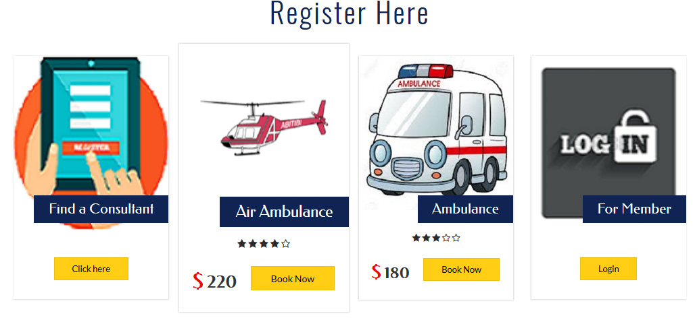

Patient can make an appointment and the time schedule will be given by massage. This is an easer process to communicate with a doctor and also get world most fast ambulance service which can ordered by online E-healthcare. This is the amazing service by which this Organization system get more populated.



Worldwide Services

For seeking medical treatment outside of the country come to the Universal Healthcare every year. The International Patient Department Universal Healthcare ensure that they feel at home during stay but also to ensure their country with a good health. Universal Healthcare provide world class medical treatment and procedures. In some easy process they can apply for treatment:-

* Throughout the website Universal Healthcare provide information about the procedure.



* Selecting The Doctor:-

Once patient choose us they can choose their doctor for treatment discuss in online with the doctor and patient will send their reports and medical histories. Universal Healthcare is made up of a large group of internationally qualified doctors and health professionals ensuring each and every patient receive the best care and treatment possible.



* 48 Hours Response Time:-

Universal Healthcare response to every query within 48 hours. Also provide the patient air ambulance service from Air Port.



* Registration: - Patient can free register from website and able to make appointment for a specialist. Also get ambulance services.

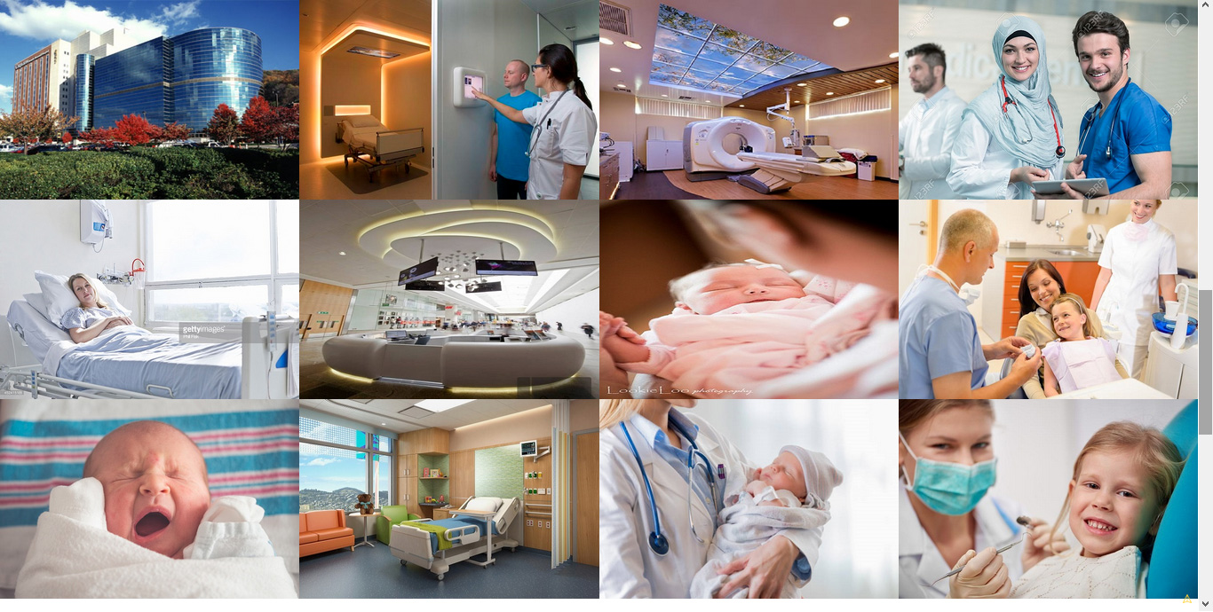Universal Healthcare Gallery

Universal Healthcare Team

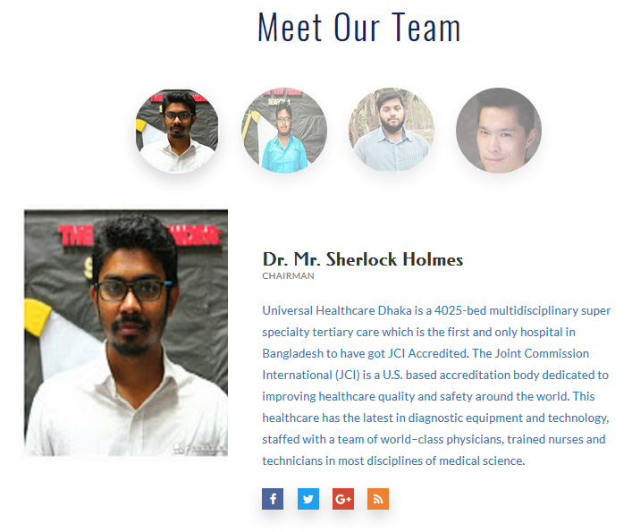

Patient Massages

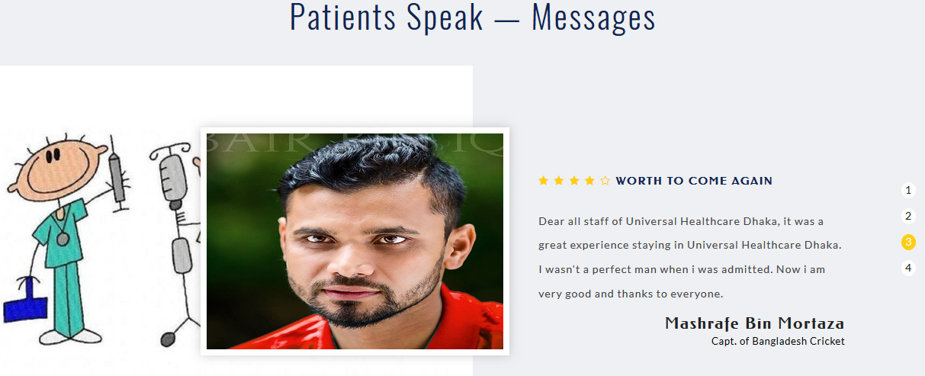

Platform

Using Database - MYSQL

Using Compiler - Mozilla Firefox

Using Language - THML, CSS, JAVA, PHP

Using Server - XAMPP

Why people use it is?

It’s efficient to use and it reduce the time. The main reason of people use this website because it’s faster and easy process. Normally, people need extra time in the ticket counter but when apply in online they get a fixed time and serial. That is it save the time, increase efficiency, strong security and human friendly.

Why I made it?

The purpose of this project is how to develop a website with different queries and also improve our web development skill.

Information Security and Friendly Use

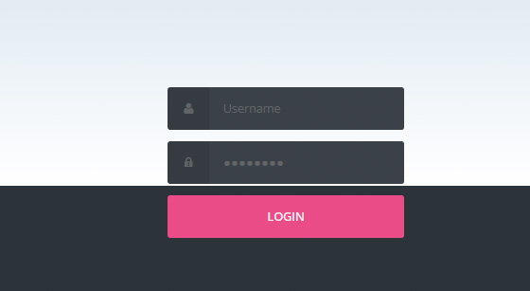

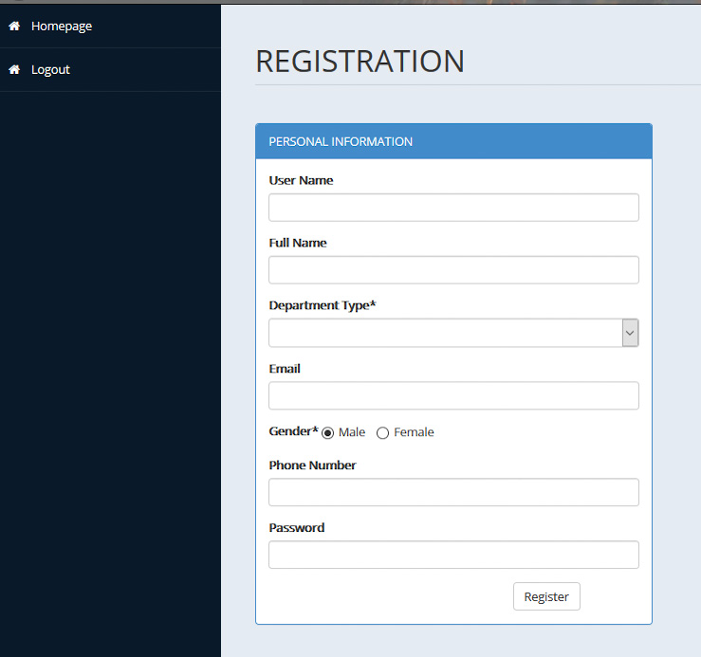

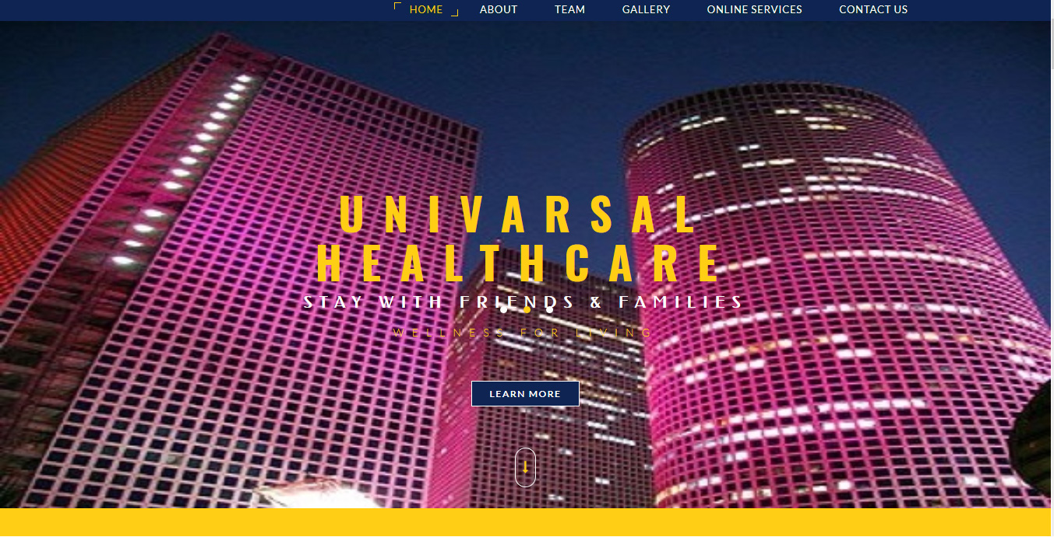Conclusions

The health system in Bangladesh relies heavily on the government or the public sector financing and setting overall policies and services delivery mechanisms. Although the health system is faced with many intractable challenges, it seems to receive little priority in terms of national resource allocation. According to the World Health Organization (WHO 2010) only about 3% of the Gross Domestic Product (GDP) is spent on health services. However, government expenditure on health is only about 34% of the total health expenditure (THE), the rest (66%) being out-of-pocket (OOP) expenses. Inequity, therefore, is a serious problem affecting the health care system. Based on a review of secondary data, the paper assesses the current challenges and opportunities of the health system in Bangladesh. The findings suggest that although the health system faces multifaceted challenges such as lack of public health facilities, scarcity of skilled workforce, inadequate financial resource allocation and political instability; Bangladesh has demonstrated much progress in achieving the health-related Millennium Development Goals (MDGs) especially MDG 4 and MDG 5. Although the country has a growing private sector primarily providing tertiary level health care services, Bangladesh still does not have a comprehensive health policy to strengthen the entire health system. Clearly, the most crucial challenge is the absence of a dynamic and proactive stewardship able to design and enforce policies to further strengthen and enhance the overall health system. Such strong leadership could bring about meaningful and effective health system reform, which will work more efficiently for the betterment of the health of the people of Bangladesh, and would be built upon the values of equity and accountability.